[To begin completing the worksheet click **File** in the top left-hand corner and then choose **Make A Copy]**

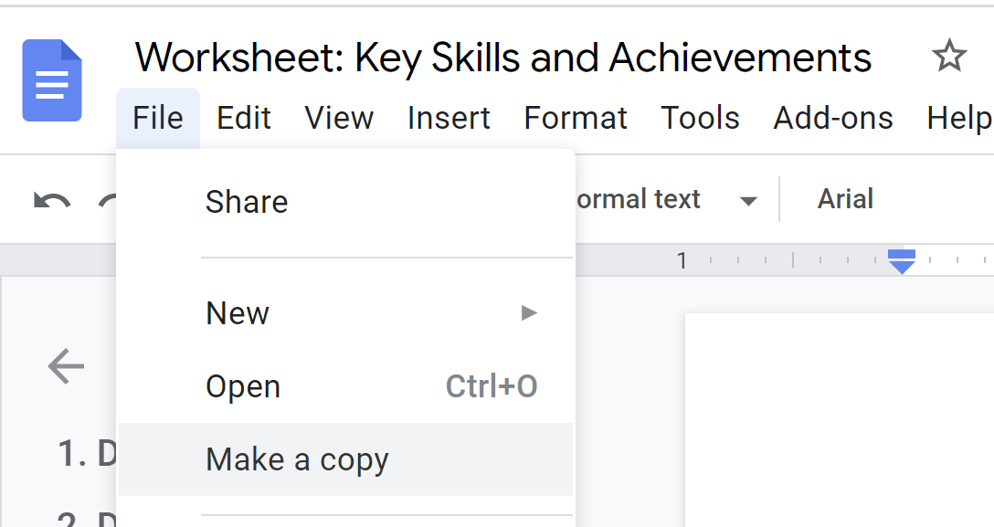

**What is the purpose of the job?** (What does the hiring manager need you for - e.g. to lead a team? Improve a system? Manage a service?)

1.

2.

3.

4.

5.

**What are the challenges facing hiring managers at your target companies?** (Focus on the job as well as trends within the industry)

1.

2.

3.

4.

5.

**How do your target companies make money? Who is their target audience?**

1.

2.

3.

4.

5.

**What are the main requirements/qualifications for your target job?** (Responsibilities, reporting relationships, education / certifications, etc.)

1.

2.

3.

4.

5.

**What are the main skills required for this job?** (E.g. **Soft skills** - time management, teamwork negotiation, leadership, communication / **Hard skills:** Microsoft Excel, troubleshooting, languages, Adobe Photoshop)

1.

2.

3.

4.

5.

**Keyword Optimisation**

**(A) Job Titles**

What are the 3 most common job titles for the role you want (E.g. Finance Assistant, Financial Assistant, Financial Coordinator)?

To do this, visit [LinkedIn Jobs](https://www.linkedin.com/jobs/)**\*** and search for your target role. Run through the first 5 pages and note the 3 most common job titles.

**\***We need to use LinkedIn for this exercise as this information is going to be used to keyword optimise your LinkedIn profile.

1.

2.

3.

**(B) Most Common Keywords**

When building your new Resume and optimising your LinkedIn profile, we need a list of the most common keywords from the job descriptions of your target roles.

**To do this:**

* Visit [LinkedIn Jobs](https://www.linkedin.com/jobs/) and search for your target role.
* Copy the job descriptions of 10 - 15 jobs and paste them into [WordCounter.net](https://wordcounter.net/).
* On the right-hand side of the page, you will see what keywords, key terms, and skills appear most frequently. **Note them down below.** Keep in mind that some keywords will not be relevant - words like “experience”, “skills”, “work”, “excellent”, etc, so stick to hard skills **(specialisms and systems)**.

**List of the most common keywords, terms, and skills:**

1.

2.

3.

4.

5.

6.

7.

8.

9.

10.

11.

12.

13.

14.

15.

16.

17.

18.

19.

20.

21.

22.

23.

24.

25.

26.

27.

28.

29.

30.